Architecture 5612
Research Methods II
Eric Sauda
F 11:00-1:40

“If we knew what it was we were doing, it would not be called research, would it?”
Albert Einstein

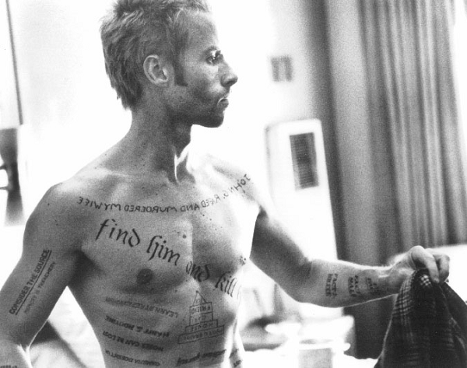
PREMISE
This course is an opportunity for each student to identify and research a topic as the focus of her/his thesis.
OBJECTIVES
- to develop a knowledge of the literature defining an important area of design computation,
- to articulate an important unanswered question within that field,
- to identify faculty from architecture and CCI to serve on the thesis committee and
- to outline the methodology needed to study that question.
METHOD
We will begin by writing a definition of the putative topic for the thesis. This statement should be brief and clearly indicate the important issues that you wish to study.
We will identify potential faculty to serve as members of the thesis committee. They will be primarily responsible for providing advice and feedback during this process. The thesis committee may include as many members as you wish, but it must include at least one faculty member from CCI and one from architecture.
You will develop a bibliography of important writing about your topic, which will include at least 25 or 30 important articles or books. You will be responsible for understanding each of these references.
You will write an explanation of the field that will define the shared concerns, the important terminology and the gaps in knowledge. This explanation will draw heavily on the bibliography, but in a way that synthesizes the common issues. It will be between 10 and fifteen pages of writing, diagrams and data.
You will propose a methodology for how to proceed with your thesis during the spring semester. You will approach this using the concept of an academic course structure as a model; you will imagine teaching students and decide what their activities might include, in what order and with what outcome.
There will be symposia at the completion of each phase that will include your thesis committee and faculty from architecture, SIS and CS.
Your final task for the semester will be to produce a written document that includes all phases of your work during the semester.

