4204/5204 Peter Wong Spring 2021 SoA UNCCharlotte
4204 / 5204

History and Theory of Architectural Space
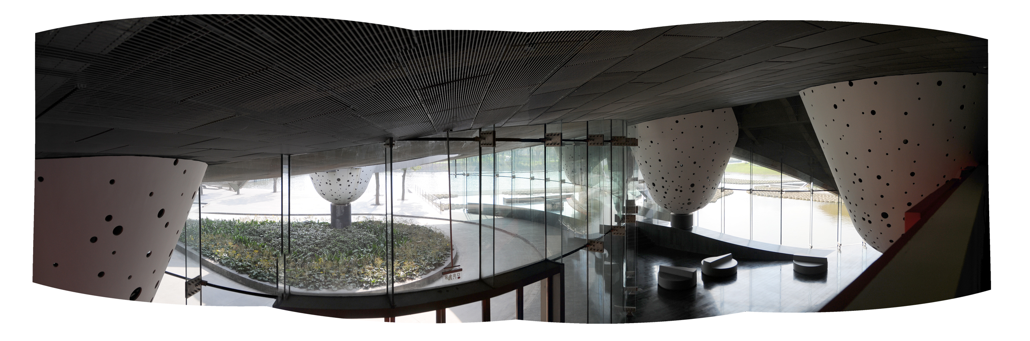
Morphosis, Giant Interactive Headquarters, Shanghai, 2010.

Human movement and action are exterior to everything: man is always on the outside, and in order to penetrate beyond surfaces, he must break them open.

Course Info
4204/5204-00_ | Sp 2021 | W 7:00-9:45p | prerequisite 4203/5203 | Peter Wong | online | plwong@uncc.edu

Premise
It's been argued that painting is about making images and sculpture about producing form. Architecture, by contrast, must appeal not only to our desire for two and three-dimensional art but also a myriad of other needs, such as necessity, comfort, human well-being, and social engagement. It must reflect economic and political influences as well as draw clues from its social/cultural climate. One of the particularities of architecture is its ability to shape and organize interior worlds, domains that allow human participation, action, and thought – a world often times absent of physical images and objects. Unlike painting or sculpture, buildings allow us to occupy physical realms – spaces that satisfy not only our sense of sight but also other sensoral experiences (e.g., tactile, aural, and olfactory readings of the environment). Such an interpretation of architecture has been largely overshadowed by a standing tradition of visual training – a model which primarily finds its roots in the arts. Hence, architects generally appreciate buildings as objects and forms rather than as a set of spatial experiences and/or values. One of the aims of this course is to inquire into whether designers should see their task as different from that of the artist and sculptor, and to question whether buildings can be conceived as a complex interplay of spatial events as opposed to only a set of physical things.

Method and Content
The class will be structured as a seminar involving lectures, readings, research, and writing. The written component fulfills the University’s undergraduate requirement for writing intensive (W) coursework. Content and themes to include: 1) Western and non-Western spatial beginnings, 2) religious space, 3) space and representation, 4) space of illusion, 5) rational space, 6) psycho/physical space, 7) modern space, 8) time and space, 9) cultural space, 10) event space, 11) digital space, 12) contemporary voids. This class will satisfy NAAB Student Performance Criterion A.1: Professional Communication Skills.

Bibliography
Basic texts: required texts from History I, II, and III. Advance texts: individual essays, articles, and chapter assigned by instructor.

Evaluations / Grading
UNCCharlotte undergraduate and graduate grading scales according to current catalogs. Distribution of course evaluation: class presentation 20%, written paper(s) 40%, project research 30%, participation and development 10%. Graduate students will be responsible for conducting literary reviews for their research and asked to conduct one seminar on a topic derived from the course research.

Henri Focillon, The Life of Forms in Art, (New York: Zone, 1992), 74.

